Web data extraction Requirement document

Suggested Code Policy:

1. Copy the Project folder structure from bellow github link.

<https://github.com/hackathonScrapping/BANK.git>

1. Use Python(Mandatory) with Beautiful Soup, Scrapy and Selenium (Feel free to use any other Python libraries)
2. Store Scrapped data with provided file name and CSV format.

Work 1:

**Scarped Data Format (File Name - BOA_Data_Deposit_<MM_DD_YYYY>.csv)**

|  |  |  |  |  |  |  |  |  |
| --- | --- | --- | --- | --- | --- | --- | --- | --- |
| Date | Bank Name | TAB Name | Product Name | Minimum Opening Balance | Minimum Balance | Maximum Balance | Interest Rate | APY |
|  |  |  |  |  |  |  |  |  |
|  |  |  |  |  |  |  |  |  |
|  |  |  |  |  |  |  |  |  |
|  |  |  |  |  |  |  |  |  |
|  |  |  |  |  |  |  |  |  |
|  |  |  |  |  |  |  |  |  |

|  |  |  |  |  |  |  |  |  |  |  |  |  |
| --- | --- | --- | --- | --- | --- | --- | --- | --- | --- | --- | --- | --- |
|  |  | |  |  |  |  |  |  | | | |  |
|  |  | |  |  |  |  |  |  | | | |  |
|  | |  | | | | | | | | | |  |
|  |  | |  |  |  | | | |  |  |  |  |

**Steps**

1. Bank URL: <https://www.bankofamerica.com/deposits/bank-account-interest-rates/> (PDF)

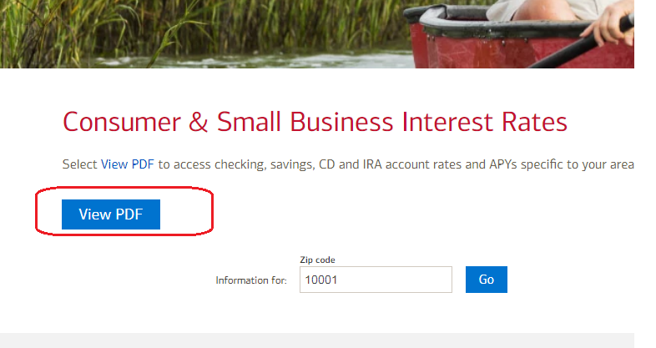

1. Scrape deposit rates from the PDF. **(PDF to be done separately)**

**Savings Rates**

**Checking Rates**

**CDs**

|  |  |  |  |  |  |  |  |  |  |  |  |  |  |  |  |  |  |  |  |  |  |  |  |  |  |  |  |  |  |  |  |  |  |  |  |  |  |  |  |  |  |  |  |  |  |  |  |  |  |  |  |  |  |  |  |  |  |  |  |  |  |  |  |  |  |  |  |  |  |  |  |  |  |
| --- | --- | --- | --- | --- | --- | --- | --- | --- | --- | --- | --- | --- | --- | --- | --- | --- | --- | --- | --- | --- | --- | --- | --- | --- | --- | --- | --- | --- | --- | --- | --- | --- | --- | --- | --- | --- | --- | --- | --- | --- | --- | --- | --- | --- | --- | --- | --- | --- | --- | --- | --- | --- | --- | --- | --- | --- | --- | --- | --- | --- | --- | --- | --- | --- | --- | --- | --- | --- | --- | --- | --- | --- | --- |
| Work 2: Capturing Mortgage data  **Capture data for both Refinance rates and Buying Mortgage rates, additional data needs to be captured from Details**  **Scarped Data Format (File Name - BOA_Data_Mortgage_<MM_DD_YYYY>.csv)**   |  |  |  |  |  |  |  |  |  |  |  |  | | --- | --- | --- | --- | --- | --- | --- | --- | --- | --- | --- | --- | | Date | Bank Name | Property Value | Loan amount | State | City | Credit Score | Loan to Value Ratio | Loan Type | Product Name | Interest Rate | APR | |  |  |  |  |  |  |  |  |  |  |  |  | |  |  |  |  |  |  |  |  |  |  |  |  | |  |  |  |  |  |  |  |  |  |  |  |  | |  |  |  |  |  |  |  |  |  |  |  |  | |  |  |  |  |  |  |  |  |  |  |  |  |   [**https://www.bankofamerica.com/mortgage/home-mortgage/**](https://www.bankofamerica.com/mortgage/home-mortgage/)    [**https://www.bankofamerica.com/mortgage/refinance/**](https://www.bankofamerica.com/mortgage/refinance/) |  |

|  |  |  |  |  |  |  |  |  |  |  |  |  |  |  |  |  |  |
| --- | --- | --- | --- | --- | --- | --- | --- | --- | --- | --- | --- | --- | --- | --- | --- | --- | --- |
|  | |  |  | |  | |  | |  | |  | |  |  |  |  |  |
|  |  | | |  | |  | |  | |  | |  | | | | | |